- Given the scenario of a School Management System, identifyrelations and write SQL to list all students with their class teacher and grade.
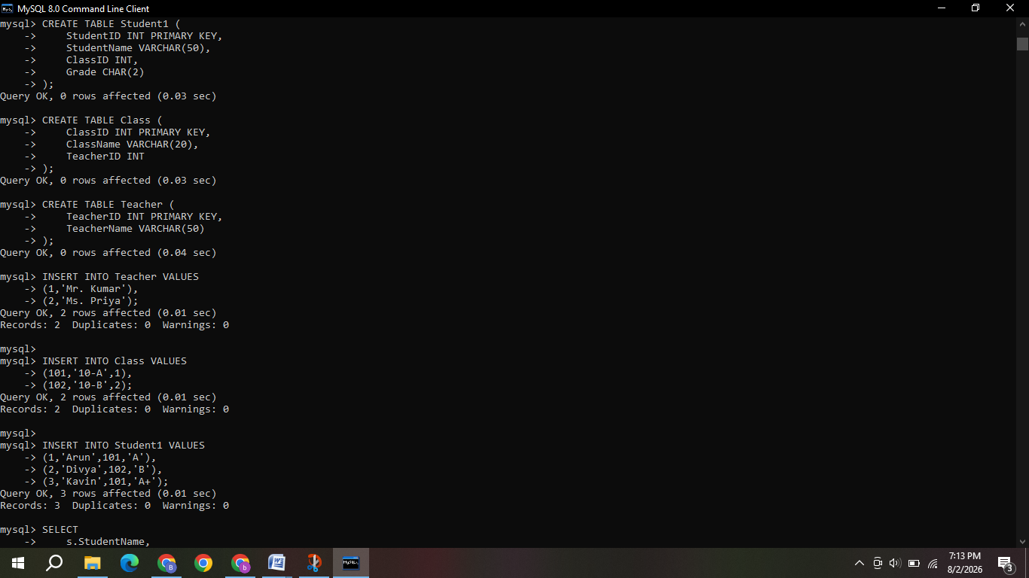
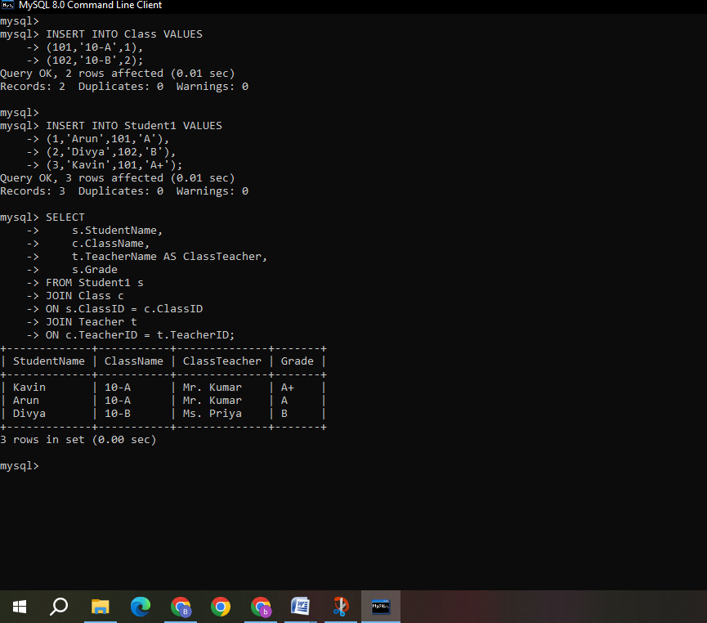

- A hospital wants to track patient appointments. Design the relational schema and write SQL to find doctors with more than 10 appointments this month.

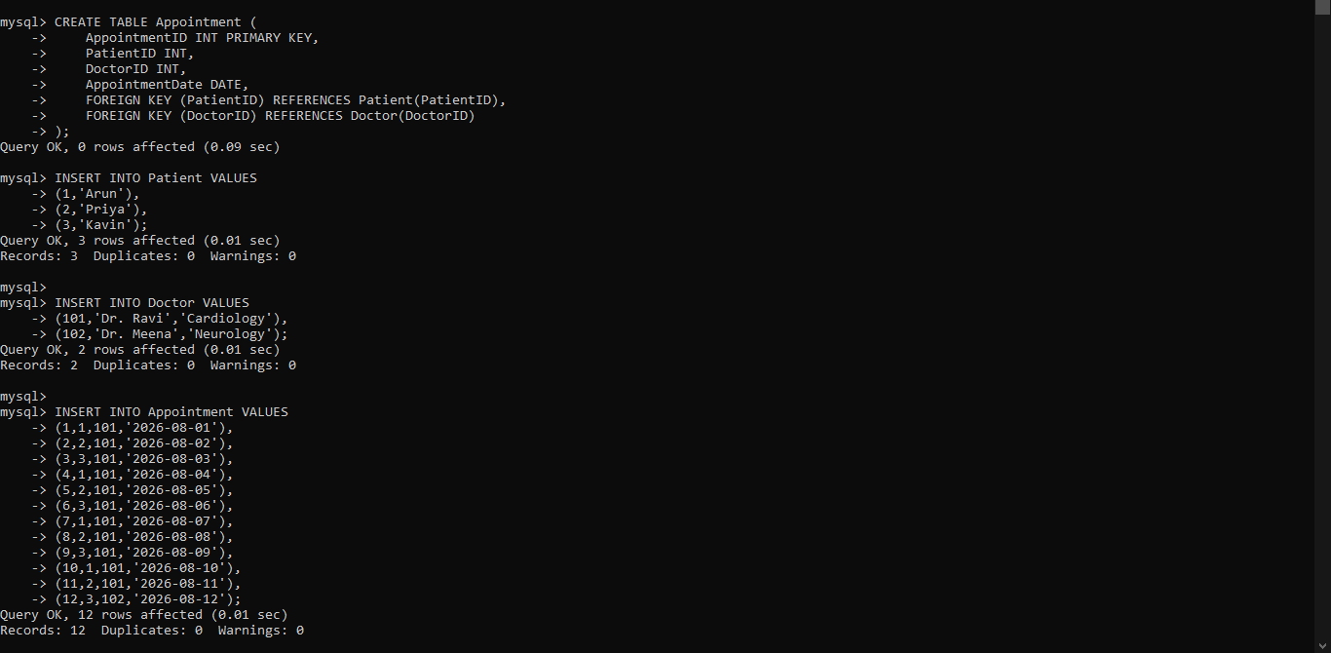
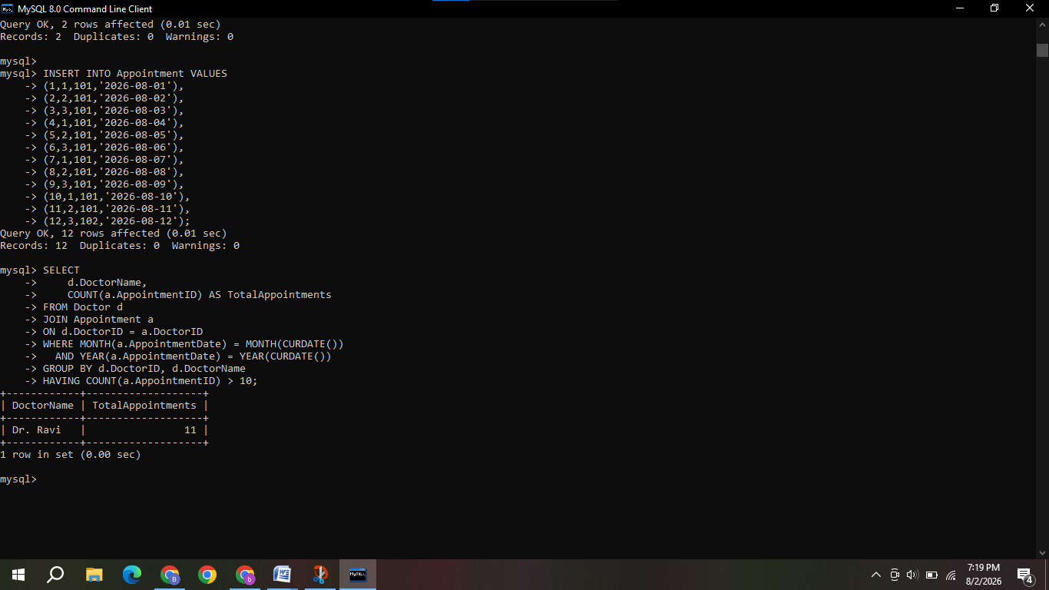

- In an e-commerce scenario, write SQL queries using sub-queries to find products that have never been ordered.

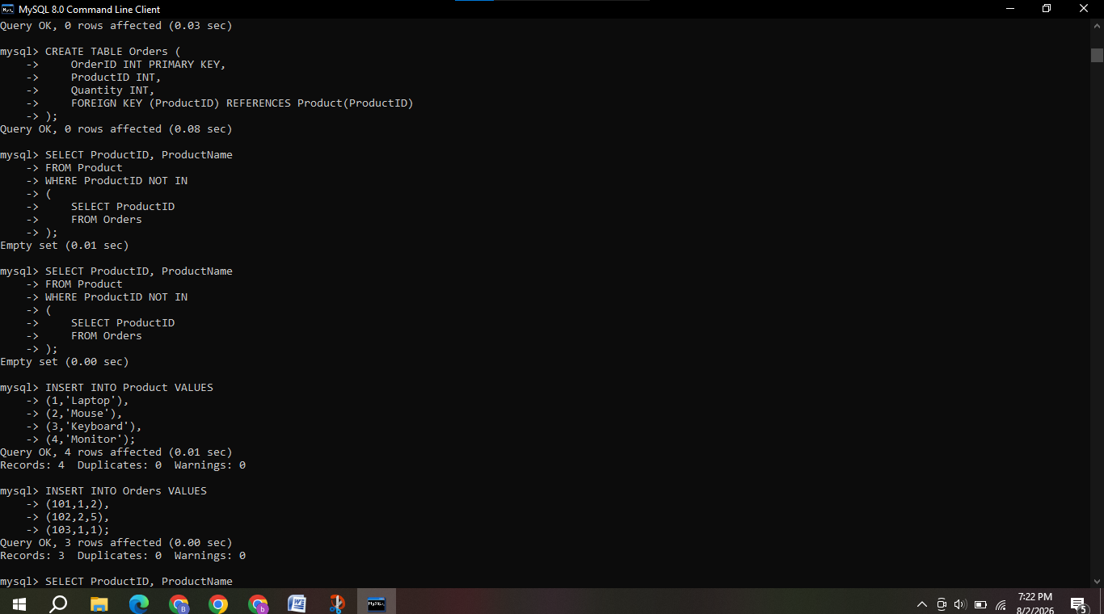
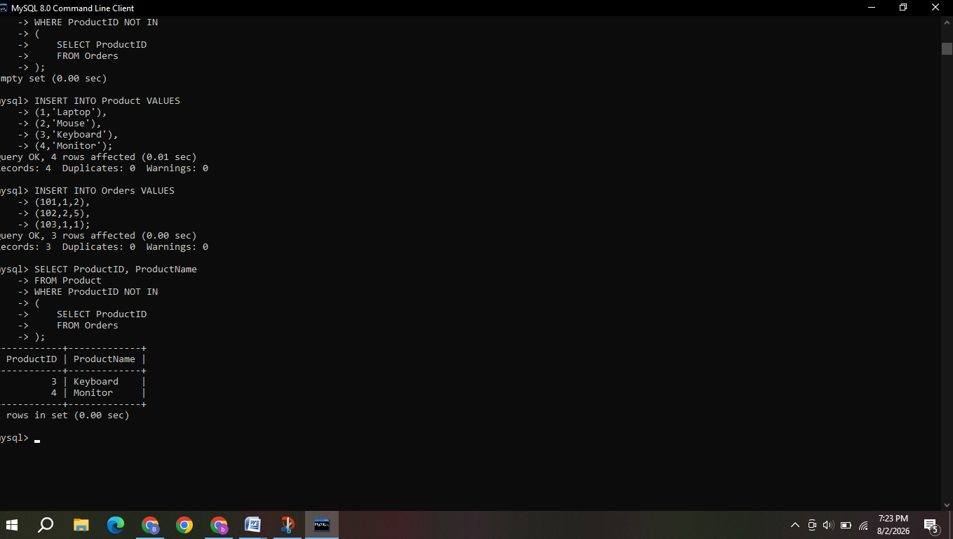

- For a university database, write relational algebra expressions to find students enrolled in both "DBMS" and "OS" courses.

For a university database, assume the relation:
ENROLLMENT(Student_ID, Course_Name)
We need to find students who are enrolled in both "DBMS" and "OS".
Relational Algebra Expression
First, find students enrolled in DBMS:
[
DBMS_Students = \pi_{Student_ID}(\sigma_{Course_Name='DBMS'}(ENROLLMENT))
]
Then, find students enrolled in OS:
[
OS_Students = \pi_{Student_ID}(\sigma_{Course_Name='OS'}(ENROLLMENT))
]
Finally, take the intersection:
[
\boxed{
\pi_{Student_ID}(\sigma_{Course_Name='DBMS'}(ENROLLMENT))
\cap
\pi_{Student_ID}(\sigma_{Course_Name='OS'}(ENROLLMENT))
}
]
Result: This expression returns the Student_IDs of students who are enrolled in both DBMS and OS courses.
Alternative using natural join: If separate relations DBMS(Student_ID) and OS(Student_ID) are available:
[
DBMS \bowtie OS
]
This also gives the students enrolled in both courses.

5) Given a payroll scenario, create a view showing employees whose salary is below department average and write a query to update their salary by 10%.
Assumed Table:
Employee(EmpID, EmpName, DeptID, Salary)
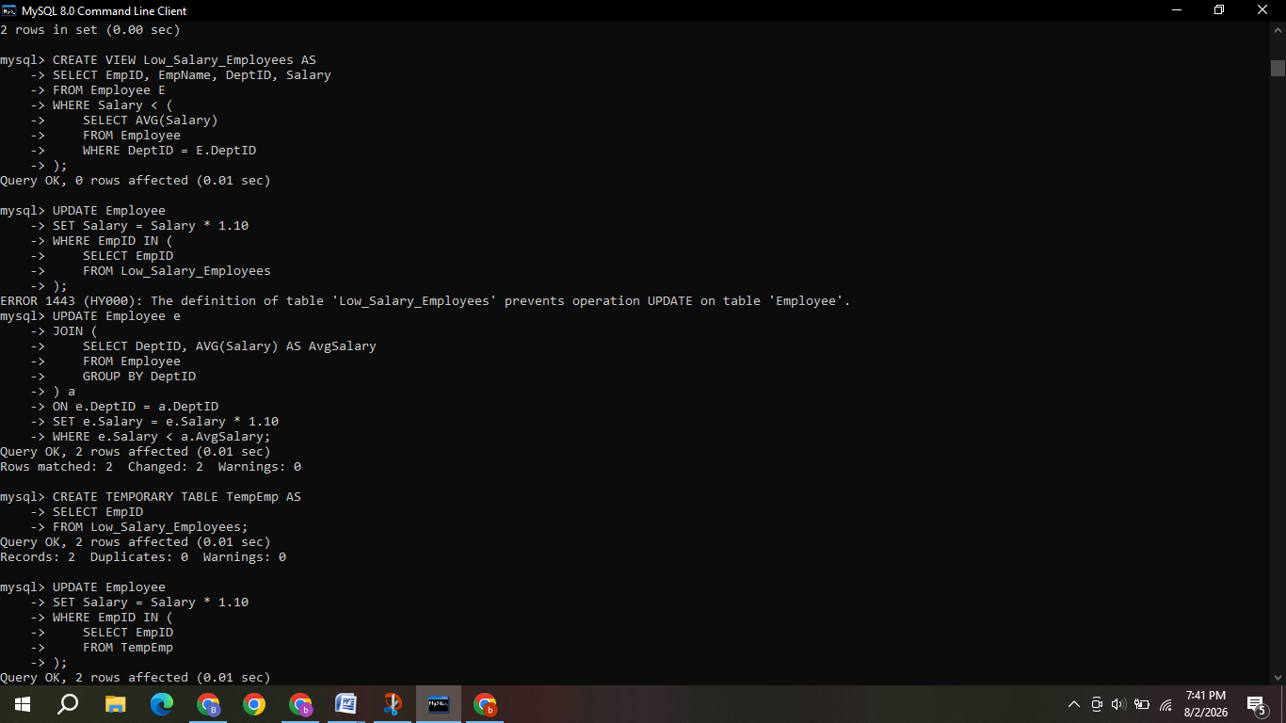
- In a banking scenario, apply JOIN operations to retrieve customer account details, transaction history, and branch information.
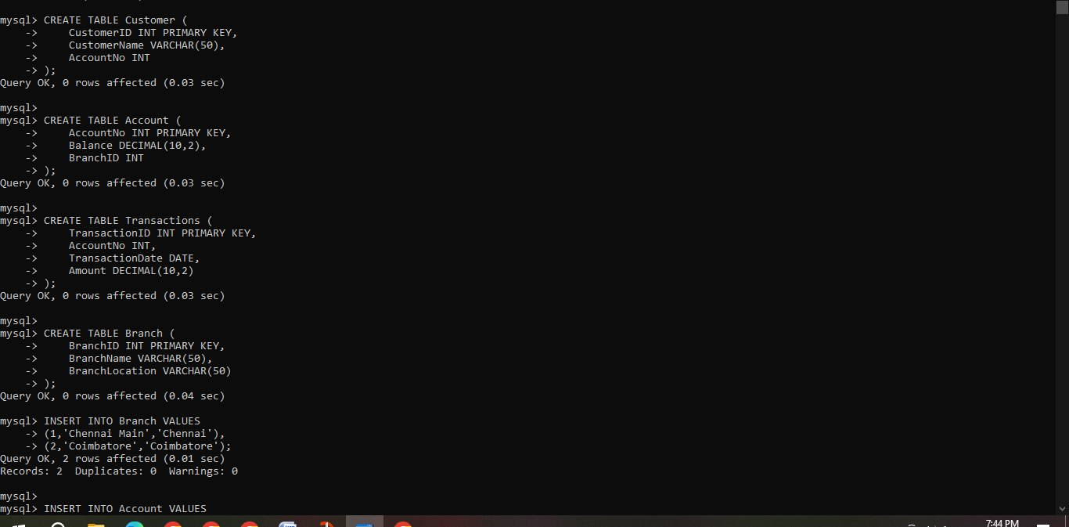
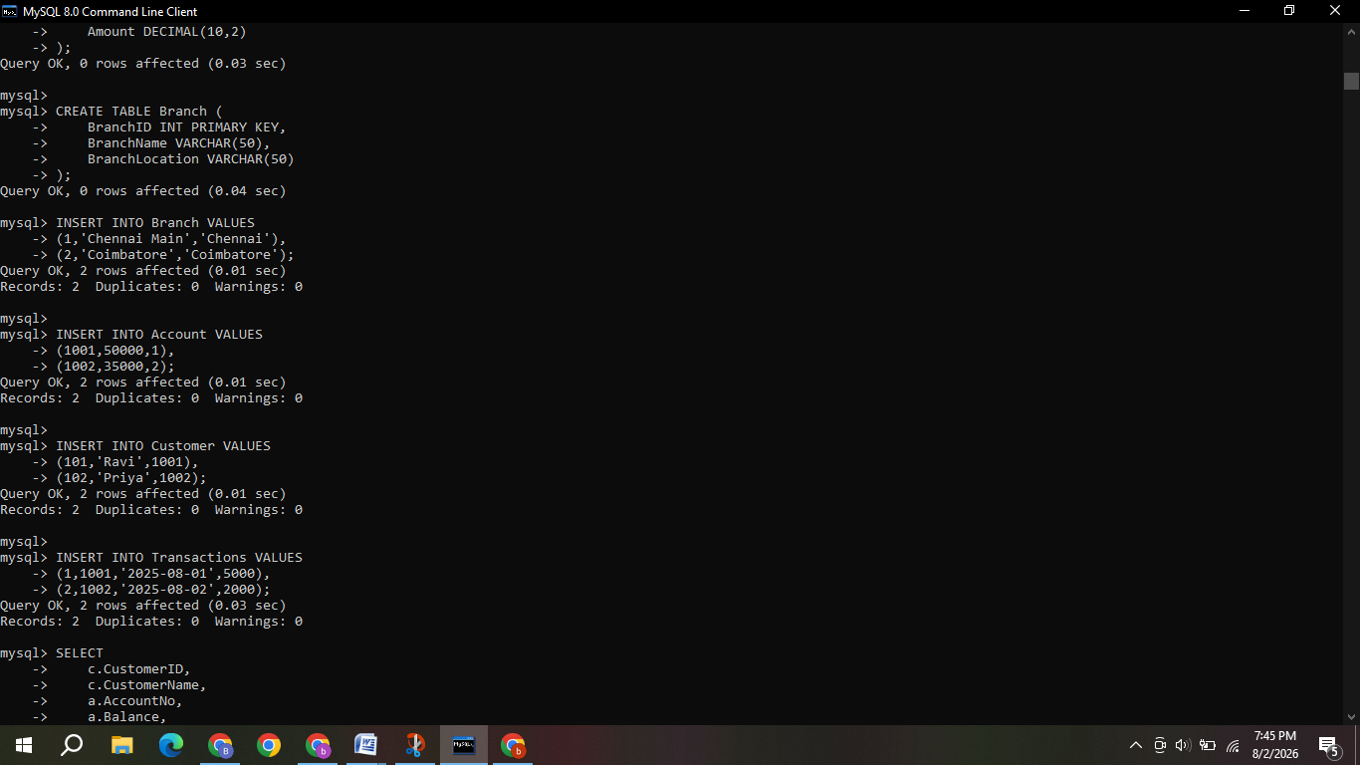
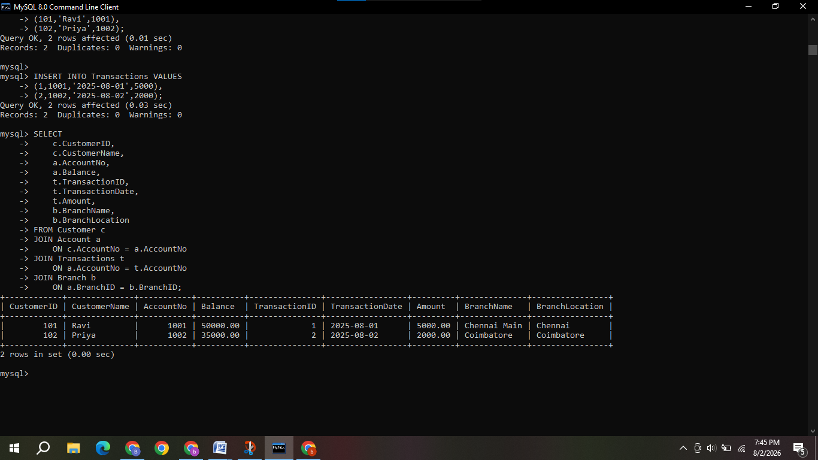

- A retail store needs daily sales summary. Write SQL with GROUP BY and HAVING to report total sales per category exceeding Rs.10,000.

Assumed Table

Sales(SaleID, ProductName, Category, Amount, SaleDate)

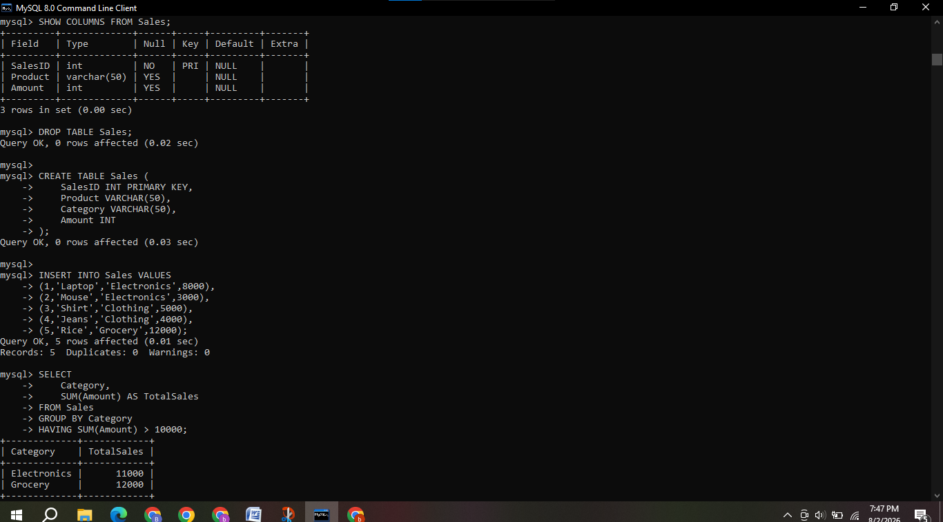

For a library system scenario, construct tuple relational calculus expressions to find members who borrowed books from all genres.

Assumed Relations
- Member(MemberID, MemberName)
- Book(BookID, Title, Genre)
- Borrow(MemberID, BookID)
Tuple Relational Calculus Expression:
{ m.MemberName |
Member(m) ∧
∀g (
∃b (Book(b) ∧ b.Genre = g.Genre)
→
∃br ∃bk (
Borrow(br) ∧
Book(bk) ∧
br.MemberID = m.MemberID ∧
br.BookID = bk.BookID ∧
bk.Genre = g.Genre
)
)
}
- Given an inventory management scenario, define CHECK and FOREIGN KEY constraints and demonstrate their enforcement through SQL.
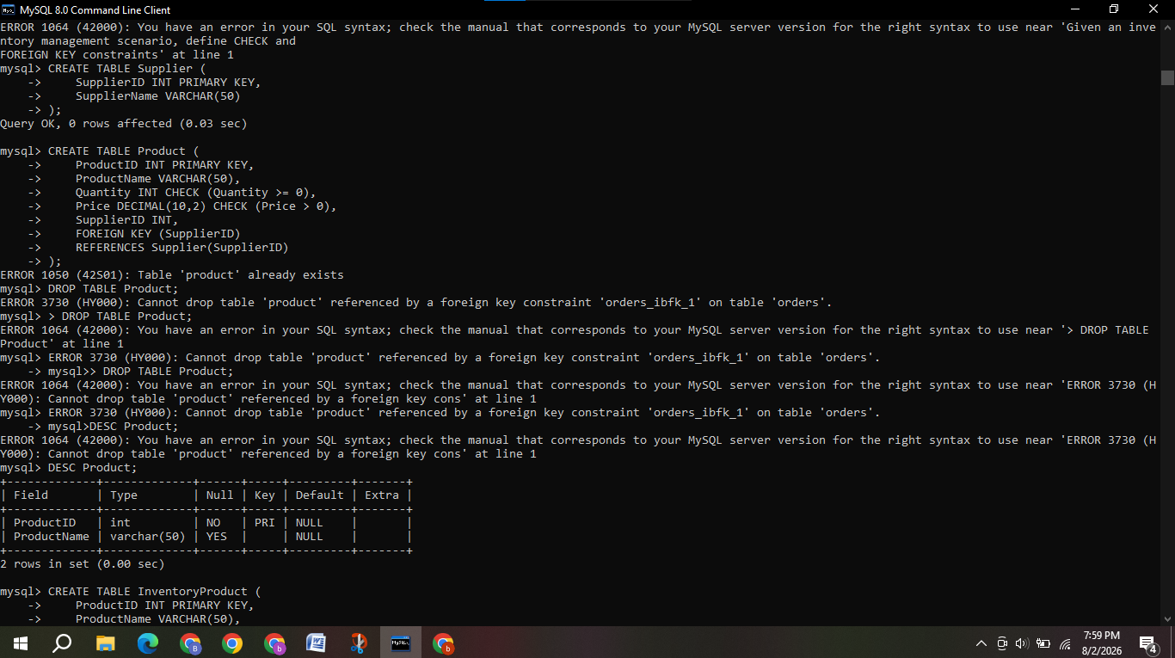
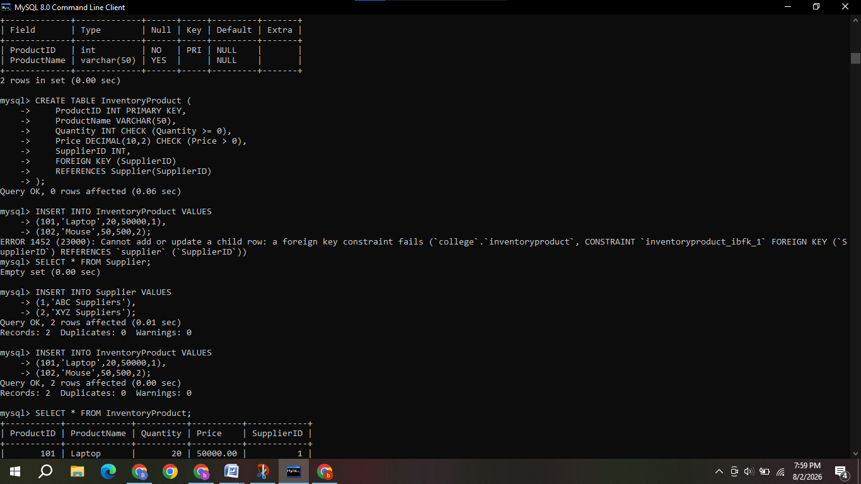
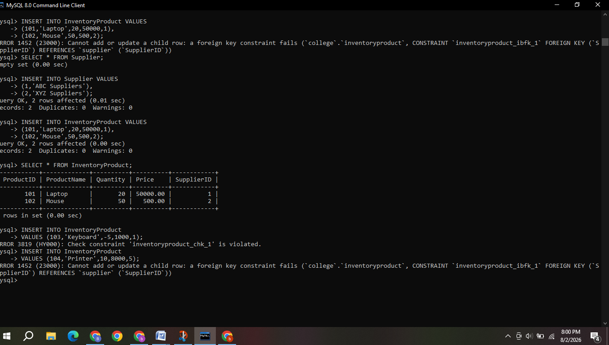

- Design a relational schema for an HR system and create materialized views for monthly attendance and performance summaries.
